**Creating Loan Account Action**

Create a new Loan Action Skill

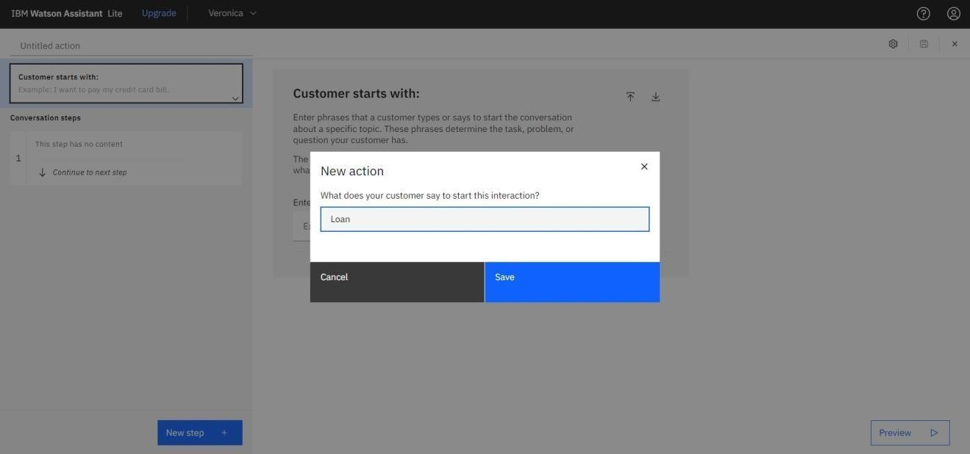

Adding steps in loan action to handle customer queries regarding Housing loan, Gold loan, Top-up loan, Student loan, and Vehicle loan.

